

**Progressive WebApps1**

**Created by:-**

**Darshan Jain**

**18CSU056**

**CONTENT**

1. **Introduction**
2. **Technology**
3. **Design**
4. **Website**
5. **Testing**

**INRODUCTION**

This website is a replica of Armani exchange website(<https://www.armaniexchange.com/wx>).

This website has been created using HTML, CSS, Bootstrap and JavaScript and has inventory functionality in which we can add, delete and edit entry of product.

**TECHNOLOGY**

The website has been made with the integrated contribution of HTML, CSS, Bootstrap and JavaScript.

**HTML**

* HTML stands for Hyper Text Markup Language
* HTML describes the structure of a Web page
* HTML consists of a series of elements
* HTML elements tell the browser how to display the content
* HTML elements are represented by tags
* HTML tags label pieces of content such as "heading", "paragraph", "table", and so on
* Browsers do not display the HTML tags, but use them to render the content of the page

**CSS**

* CSS stands for Cascading Style Sheets
* CSS describes how HTML elements are to be displayed on screen, paper, or in other media
* CSS saves a lot of work. It can control the layout of multiple web pages all at once
* External stylesheets are stored in CSS files

**BOOTSTRAP**

Build responsive, mobile-first projects on the web with the world’s most popular front-end component library.

Bootstrap is an open source toolkit for developing with HTML, CSS, and JS. Quickly prototype your ideas or build your entire app with our Sass variables and mixins, responsive grid system, extensive prebuilt components, and powerful plugins built on jQuery.

**JAVASCRIPT**

JavaScript is a very powerful **client-side scripting language**. JavaScript is used mainly for enhancing the interaction of a user with the webpage. In other words, you can make your webpage more lively and interactive, with the help of JavaScript.

**DESIGN**

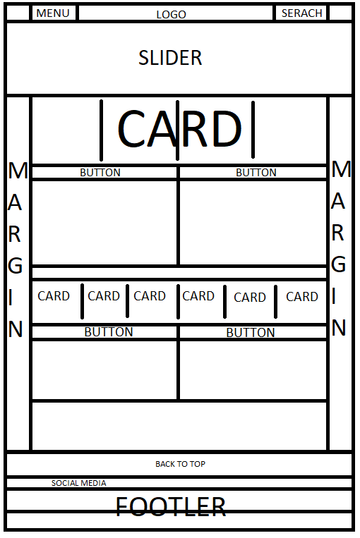

**WEBSITE**

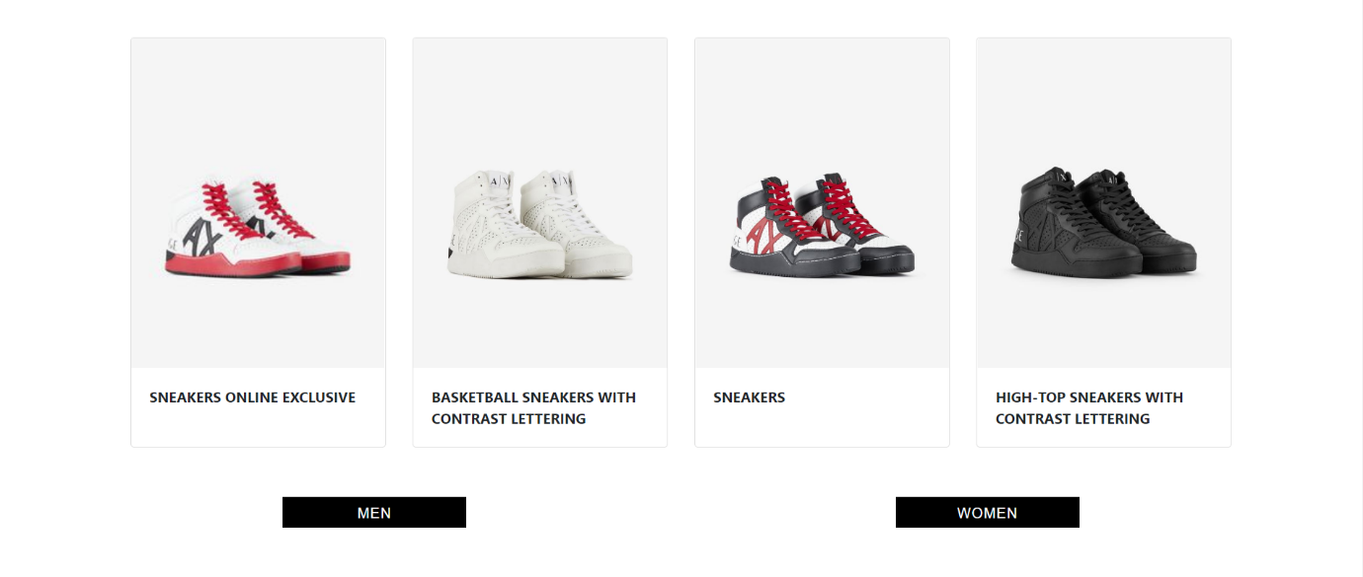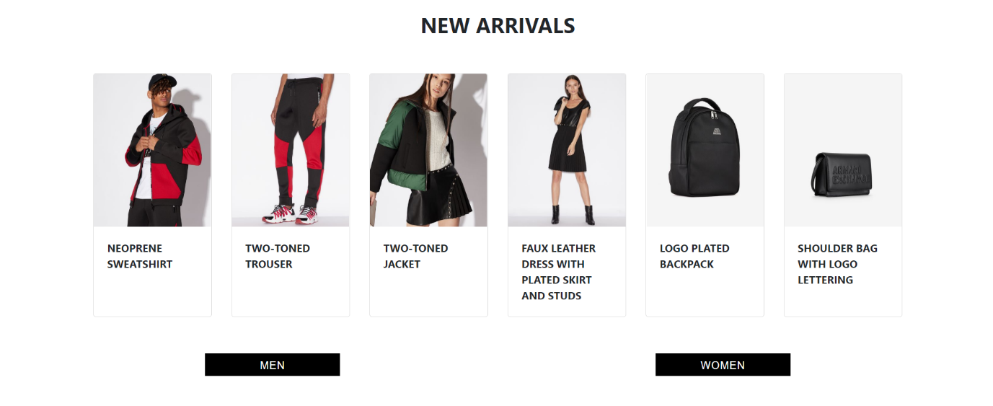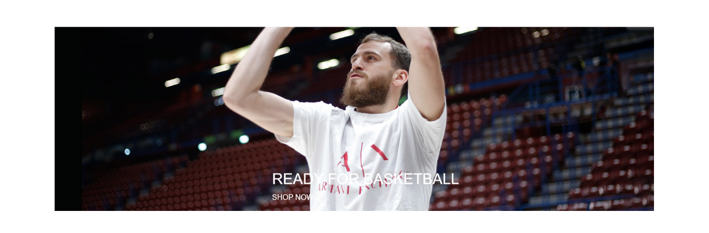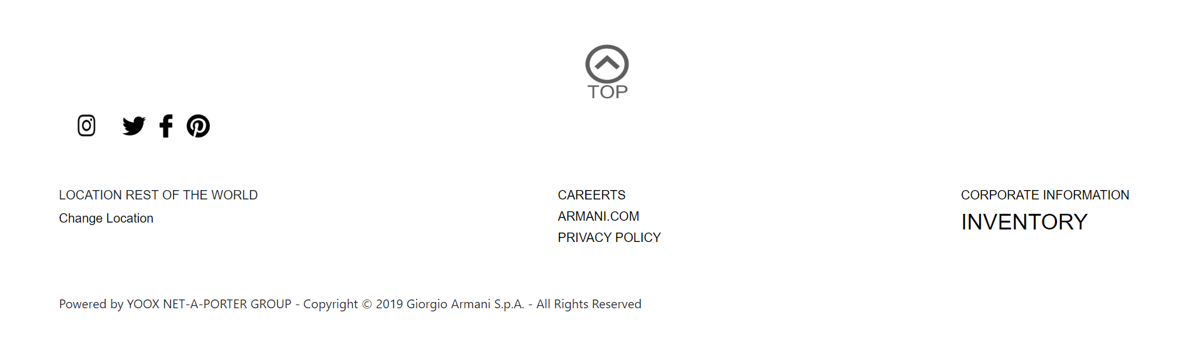

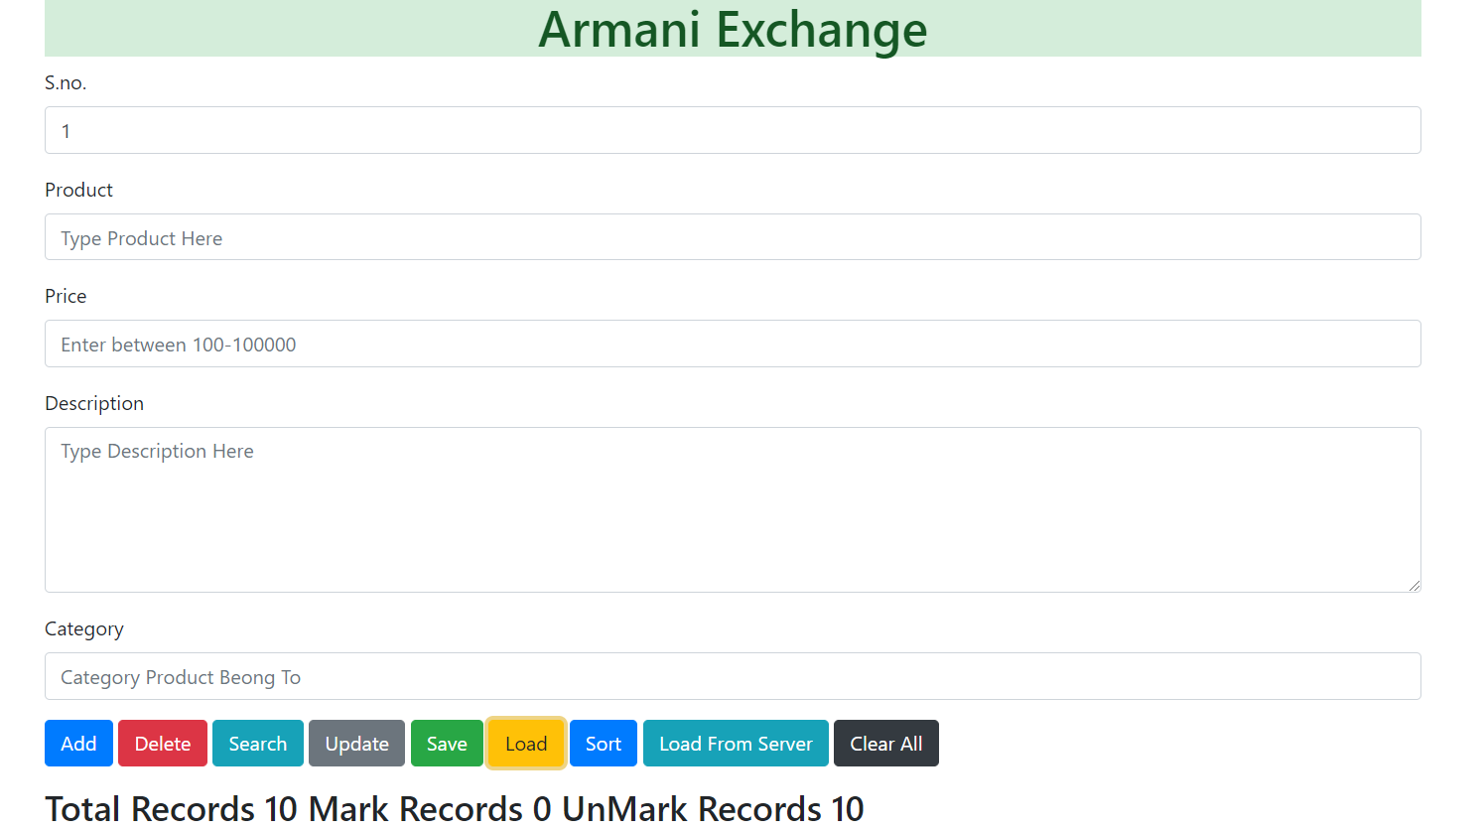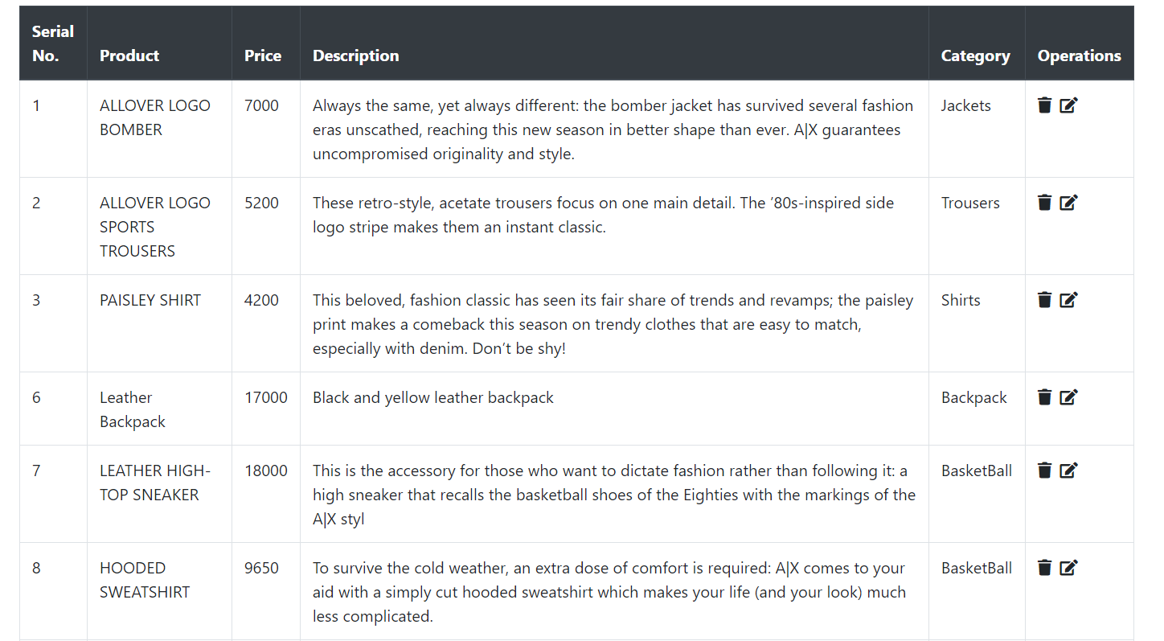

**TESTING**

Created:-



Original:- 